Algebra 2 Unit 2
Please be sure to look at quiz #2.1, the 2 review sheets I gave out, as well as the Spiral Review for Quiz #2.2 on my website!

- Reducing roots/ solutions/ answers while using the quadratic formula
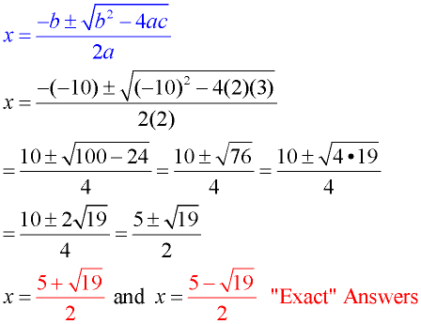
Let’s say you are asked to solve the equation $2x^{2}-10x+3=0$ and you decide to use the Quadratic formula to solve the equation. Please review the process for how you SIMPLIFY your final exact answers!

- Separating your final answer into simplest a + bi form
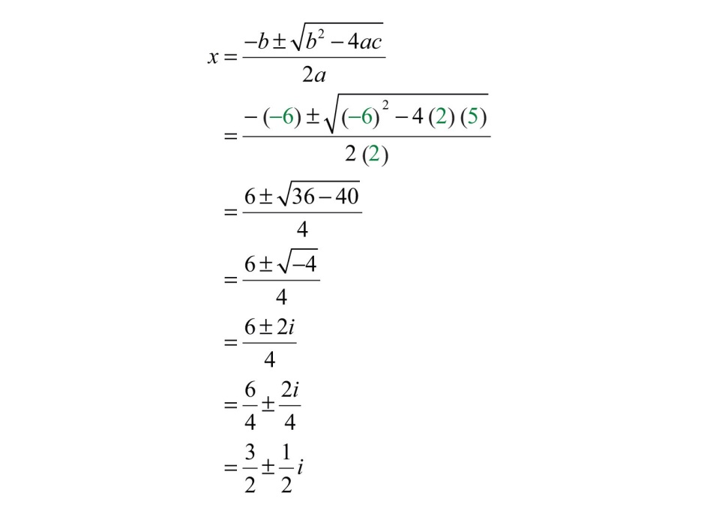
Let’s say you are asked to solve the equation $2x^{2}-6x+5=0$ and you decide to use the Quadratic formula to solve the equation. Please review the process for how you WRITE your answer in SIMPLEST a + bi form.

- Solving quadratics using Factoring/ Formula/ CTS
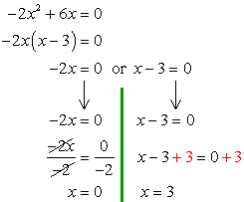
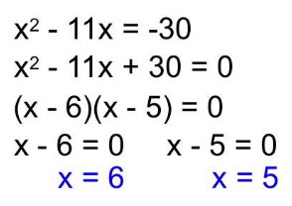
To SOLVE any quadratic equation (highest degree is an $x^{2}$) in the form $ax^{2}+bx+c=0$, you can use factoring, the quadratic formula, or completing the square. The Quadratic Formula (and CTS) will ALWAYS work! Please review the examples below (and see the examples above).

- Isolating radical before squaring both sides
To SOLVE a radical equation, make sure you ISOLATE the radical first! Complete PEMDAS backwards. Also, please be sure to CHECK for extraneous roots! See the example below.
$$20+2\sqrt{x^{2}-4x-5}=4x$$
$$2\sqrt{x^{2}-4x-5}=4x-20$$
$$\sqrt{x^{2}-4x-5}=2x-10$$
$$({\sqrt{x^{2}-4x-5})}^{2}={(2x-10)}^{2}$$
$$x^{2}-4x-5=(2x-10)(2x-10)$$
$$x^{2}-4x-5=4x^{2}-40x+100$$
$${3x}^{2}-36x+105=0$$
$$x^{2}-12x+35=0$$
$$(x – 7)(x – 5) = 0$$
$$x = 7, x = 5$$
$$\{5, 7\}$$

- Recognizing when to factor by the DOTS method
Please review the3 examples below.
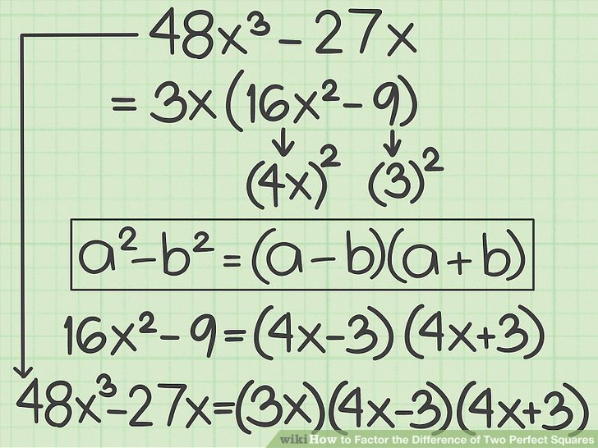
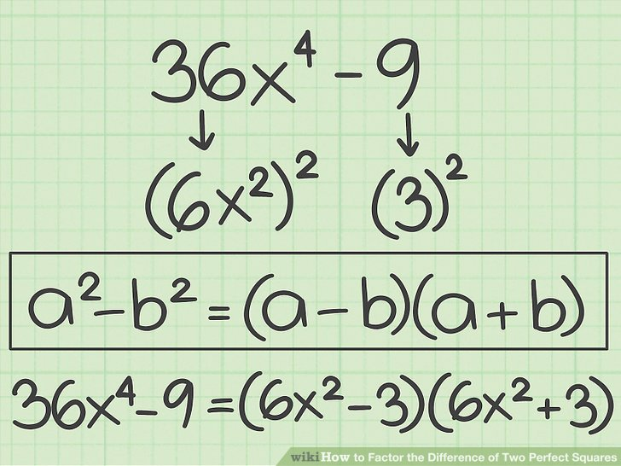
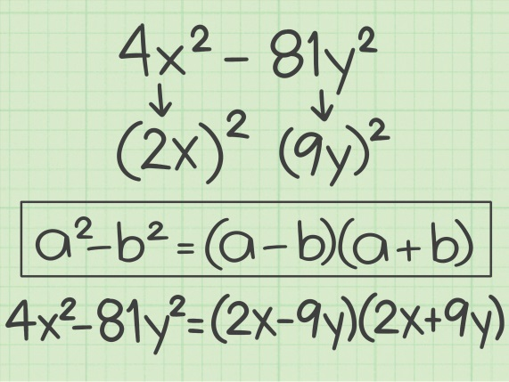
- Remembering i is on the calculator and using it to check your answers!
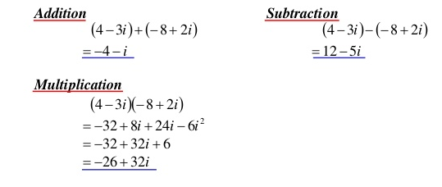

- Factoring completely
To FACTOR an expression, check for GCF, DOTS, Trinomial, and Grouping. If it says factor completely, you USUALLY need to factor twice. Please review the examples below:
$24x^{3}+14x^{2}+2x$ $12x^{2}-27$
$2x(12x^{2}+7x+1)$ $3(4x^{2}-9)$
$2x(3x+1)(4x+1)$ $3(2x+3)(2x-3)$

- Keeping vertex form separate from focus and directrix formula
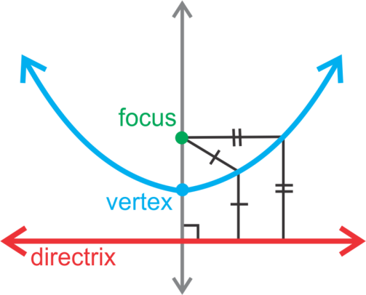
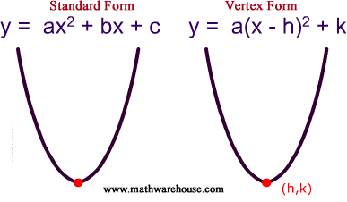
$y= ±\frac{1}{4p}{(x-h)}^{2}+k$

You only use the focus and directrix form of a parabola when you are asked to find the equation of the parabola that is equidistant from a point and a line. If they ask you to convert between standard form and vertex form, simply find a and the vertex and substitute in. Review the examples below.
Convert ${2x}^{2}+24x+64=y$ into vertex form.
a = 2
Vertex (-6, -4)
$2{(x+6)}^{2}-4=y$
Convert $y= {2(x+3)}^{2}-22$ into standard form.
a = 2
Vertex (-3, -22)
$y=2\left(x+3\right)\left(x+3\right)-22$
$y=2{(x}^{2}+6x+9)-22$
$y=2x^{2}+12x+18-22$
$y=2x^{2}+12x-4$

- Simplifying cubic roots vs. square roots
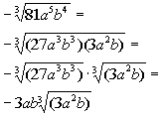
If you are asked to SIMPLIFY square roots, use perfect squares. If you are asked to simplify cubic roots, use perfect cubes. Please review the examples below.
