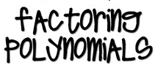
- Is there a GCF?
- Can you factor by the DOTS method?
- Is it a TRINOMIAL?
- Can you FACTOR BY GROUPING?
- Did your break down all of the factors into PRIME factors?

- Factor each of the following completely:
- $2ax+3a+4x+6$ b. $x^{3}- x^{2}-10x+10-3x^{2}+3x$ c. $6x^{2}+27x-15$
*please complete b using Factor by Grouping*

d. $81x^{8}-1$

- What is another word to represent the ROOTS of a function?
- What TYPE of roots are there?
- How do you determine how MANY roots a function has?
- How do you WRITE a FACTOR if you know a ROOT?

- Determine algebraically the roots of the function $f\left(x\right)= x^{3}- x^{2}-12x$.

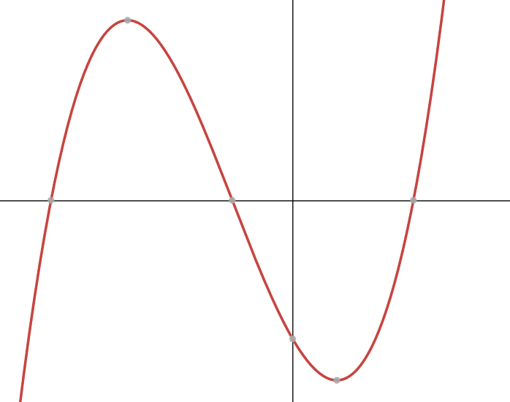
- Given the graph to the right,
  - Write the zeros of the function.
  - List out all of the factors of the function.
A
B
-4
  - Determine the sign of “a”.
  - Write a possible equation for the function.

- What is STANDARD FORM of a quadratic equation?
- What are the 4 different methods for SOLVING a quadratic equation?
- When you solve for “x”, what does that value represent on the GRAPH of a quadratic function?

- Solve the equation $3x^{2}-2x+2=0$. Express the answer in simplest $a+bi$ form.

- Solve algebraically for all values of $x$: $\sqrt{2x+13}-5=x$

- What is VERTEX form of a parabola?
- What is the EQUATION of a parabola if you know the focus and directrix?
- What does (h, k) stand for?
- What does p stand for?

- Given the equation $y= \frac{-1}{4}{(x-3)}^{2}+2$, determine
  - The coordinates of the vertex.
  - The value of “p”.
  - If the parabola opens up or down.
  - The equation of the directrix.
  - The coordinates of the focus.

- Determine an equation for the parabola with focus $(-3,6)$ and directrix $y=2$. (Use of the grid is optional.)

***Please be able to recall information from Unit 1, such as Operations with Polynomials, Operations with Complex Numbers, and Simplifying Radicals***

