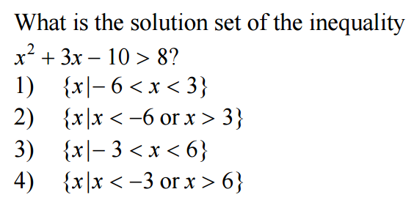
1.

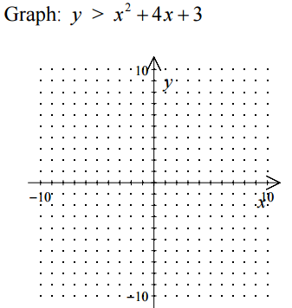
2.

3.

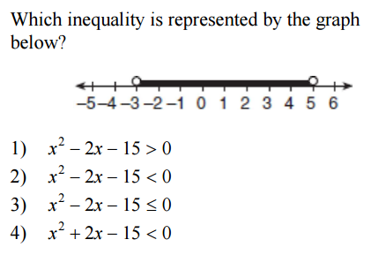
4.

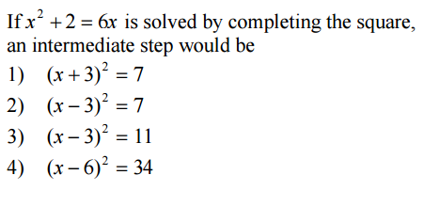
5.

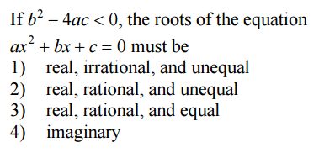
6.

7. Solve the following system of equations
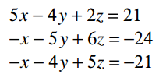

8. Solve the following system of equations
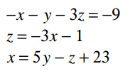

9. Solve the following system of equations
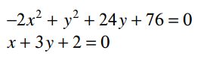

10. Simplify the following in to simplest a + bi form
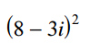

11. Which values should be given to a, b, and c so that the linear system shown has (-1, 6, 1) as its only solution?
6r − s + 3t = a
5r + 5s − 5t = b
3r − s + 4t = c

