I. Multiple Choice - Answer each question in this part on the line provided. Each question in this part is worth 2 points.

____ 1.
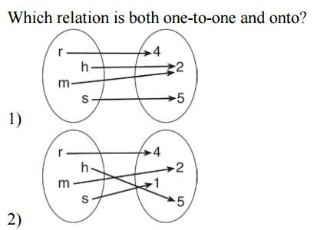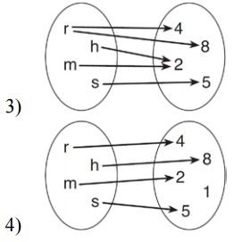

____ 2.

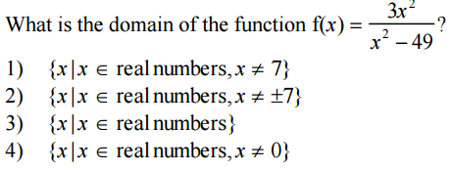
____ 3.

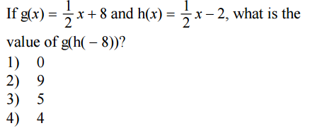
____ 4.
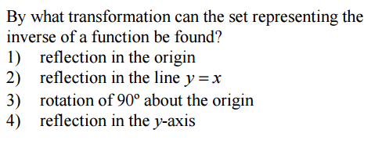
____ 5.
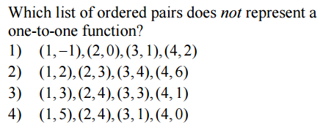
____ 6. The graph of the quadratic function includes the following coordinates: A(0, 16), B(2, 4), and C(5, 31). What are the new coordinates based on the transformation $g\left(x\right)=f\left(-x\right)?$
1) | A’(16, 0), B’(4, 2), C’(31, 5) | 3) | A’(0, 16), B’(-2, 4), C’(-5, 31)
2) | A’(0, -16), B’(2, -4), C’(5, -31) | 4) | A’(0, -16), B’(-2, -4), C’(-5, -31)

II. Each question is worth 4 points. Partial credit will be allowed. Show all work in order to reveive full credit. A correct response with no work shown will receive only one credit.

7. Consider the functions $f\left(x\right)=3x+2$ and $g\left(x\right)= \frac{8-x}{3}$

a) Find

b) Solve the equation

.

8.
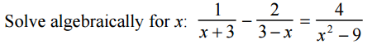

.

.

III. Each question is worth 6 points. Partial credit will be allowed. Show all work for full credit. A correct response with no work shown will receive only one credit.

10. For the given relation $f\left(x\right)=3(2x-5)$

(a) State the inverse.

(b) Prove that your result is correct using compositions.

.

11. Classify the symmetry of each function as even, odd, or neither. Use the justification box to justify your answer.

Function | Classification | Justification
$$f\left(x\right)=-5x^{2}+3x^{4}$$

$$g\left(x\right)=3x^{2}-7$$

$$h\left(x\right)=2x^{3}+3x-10$$

$$k\left(x\right)=2x^{5}+3x$$

