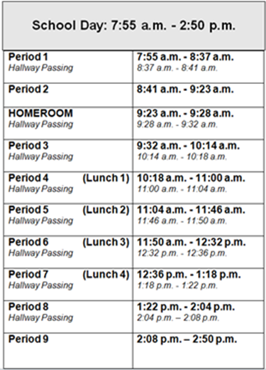 **Common Core Algebra 2**

Mrs. Casano

Citizenship Academy - class: room 338 office: room 213

[scasano@albany.k12.ny.us](mailto:scasano@albany.k12.ny.us) AHS Phone #: (518) 475-6200

scasano.weebly.com



*Text @mrscasan to* (919) 267-2939 *to receive*

*important text messages about class*

**GRADING POLICY:**

* Tests………………………..............…..40%
* Quizzes…………………………..…….35%
* Benchmark Exams…………..…....10%
* Formative Assignments…….......15%

**WHAT YOU NEED FOR THIS CLASS:**

* Pen or pencil
* Math binder ***OR*** notebook and folder

** **You will probably use *two* large notebooks for this class; we take a lot of notes\*\***

**Note:** If you intend to buy a calculator, the suggested calculators are Texas Instruments TI-84

*(TI-84 calculators will be available in class daily)*

**Formative Assignments:** Include the following

* **Pick Your Points (PYPs):** These assignments will be given in class the day after each unit test. They will be cumulative and your goal will be to earn as many points as possible on the assignment by choosing which question you want to do in that class period. If you are absent the day of a test, you will make up the test in lieu of this assignment.
* **Homework:** Homework will be assigned almost daily. It is checked at the beginning of class, and each assignment is worth 4 points. Your grade is assigned based on effort. (i.e. if you try every problem –with work shown, you get 4/4, if you try half the problems you get 2/4) A point is deducted each day an assignment is late. An answer key will be provided for the textbook and we will go over HW in class the day after it is assigned.
* **Cumulative Reviews (CRs):** The purpose of these assignments is to help you review, reinforce, and easily recall topics you should know from previous math courses and the topics you learn in this course. CRs will be assigned on the same day as every quiz and due dates will vary. These will be similar to PYPs, but will be take-home assignments. Late CRs are not accepted.
* **Warm-Ups & Exit Tickets:** Warm ups are assigned daily, but not always graded. Warm ups and exit tickets will occasionally be collected and graded to check in on how well you learned a certain lesson. Extra time is not permitted if a student arrives late without a pass.

**Quizzes:** You will typically have a quiz one to two times per unit. If you are absent the day of a quiz, you must make it up upon return. You will have until the following test or quiz (whichever comes first) to make up the missing quiz. Come see me if there are extenuating circumstances.

**Tests:** A test will be given at the end of every unit. All tests are cumulative, but test more heavily on the current unit. If you are absent the day of a test, the make-up rules are the same as for quizzes. Some tests are two-days for this course. Come see me if there are extenuating circumstances.

**Benchmark Exams:** These are cumulative tests that will be throughout the year.

**\*Note:** Students are expected to use their agendas to keep track of homework/assignments and test/quiz dates. Agendas are required for all passes to leave the classroom.



**Extra Help:**

* Available with me in our classroom 1-2 times per week (dates posted weekly)
* Available Mon-Thurs from 3-5 after school with tutors (location TBD)

**= Algebra 2 Units of Study =**

**Unit 1:** Polynomials & Complex Numbers

**Unit 2:** Quadratic Functions

**Unit 3:** Functions &Systems of Equations

**Unit 4:** Rational Functions

**Unit 5:** Trigonometry & The Unit Circle

**Unit 6:** Trigonometric Graphs

**Unit 7:** Exponents & Logarithms

**Unit 8:** Regressions and Sequences & Series

**Unit 9:** Probability

**Unit 10:** Statistics

**= A2 Facts/Course Description =**

* This course is an extension of the topics learned in the Algebra 1 curriculum.
* This course moves faster and is more rigorous than Algebra and Geometry, but if you work hard, study, and ask for help when needed, you can be successful
* I openly welcome any feedback you have for me about the pacing of the course, what works, and what doesn’t work for you with learning the course material.
* This course is worth *one* credit, and has a culminating regents at the end of the year.
* Both this course & the regents exam ARE required for an *advanced* regents diploma
* This course is NOT your only option for a *regents* diploma

**LATE/ABSENT POLICIES:**

If you are **late** to class, you are expected to have a pass.

If you are **absent** from class you are expected to make up all missing work. Zeros are assigned for past assignments that are not done until they are made up.

**= Classroom Expectations =**

* Show up to class on time
* Be prepared for class
* Come with a positive attitude
* Put forth your best effort every day in class

***As the teacher, I reserve the right to amend the syllabus throughout the course of the year.***

***All students will be made fully aware of any changes to the syllabus.***