Name: _________________________________ Algebra II
Score: ______ / 13
Period: _____________ Cumulative Review #1.1
Directions: Show all work in order to receive full credit (including multiple choice questions). A correct answer with no supporting work will only receive one credit. Be sure to show all appropriate formulas and formula substitutions as part of your work.
- If $\left(a^{3}+27\right)=\left(a+3\right)\left(a^{2}+ma+9\right)$, then $m$ equals [correct answer = 1 points, work = 2 points]
1) | -9
2) | -3
3) | 3
4) | 6

- Write $-\frac{1}{2}i^{3}\left(\sqrt{-9}-4\right)-3i^{2}$ in simplest $a+bi$ form. [4 points]

- The Beaufort Wind Scale was devised by British Rear Admiral Sir Francis Beaufort, in 1805 based upon observations of the effects of the wind. Beaufort numbers,$B$, are determined by the equation $B=1.69\sqrt{s+4.45}-3.49$, where $s$ is the speed of the wind in mph, and $B$ is rounded to the nearest integer from 0 to 12.
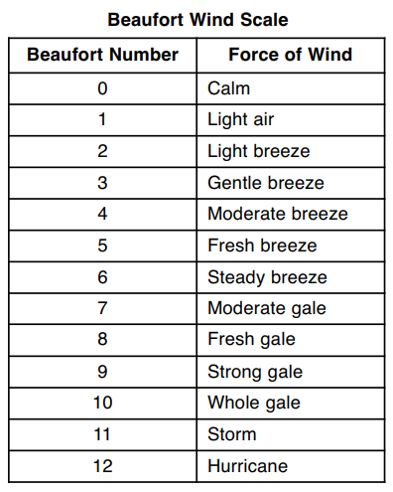
- Using the table above, classify the force of wind at a speed of 30 mph. Justify your answer. [2 points]

- In 1946, the scale was extended to accommodate strong hurricanes. A strong hurricane received a $B$ value of exactly $15$. Algebraically determine the value of $s$, to the nearest mph. [4 points]

