Name: _________________________________ Algebra II
Score: ______ / 25
Period: _____________ Cumulative Review #3.1
Directions: Show all work in order to receive full credit. A correct answer with no supporting work will only receive one credit. Be sure to show all appropriate formulas and formula substitutions as part of your work.
- Evan graphed a cubic function, , and determined the roots of to be and 2. What is the value of b, if ? [show all work for full credit]
- 1 (b) 2 (c) -1 (d) -2

- Irma initially ran one mile in over ten minutes. She then began a training program to reduce her one-mile time. She recorded her one-mile time once a week for twelve consecutive weeks, as modeled in the graph below. 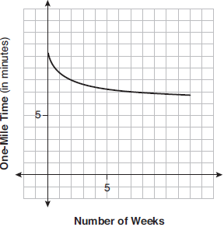
Which statement regarding Irma’s one-mile training program is correct? [show all work for full credit]
1) | Her one-mile speed increased as the number of weeks increased. | 3) | If the trend continues, she will run under a six-minute mile by week thirteen.
2) | Her one-mile speed decreased as the number of weeks increased. | 4) | She reduced her one-mile time the most between weeks ten and twelve.

- What is the solution when the equation is solved for x, where w is a positive integer? [show all work for full credit]
- $-1$ (b) $0$ (c) $6$ (d) $±i$

- Determine for which polynomial(s) is a factor. Explain your answer.
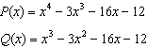

- The completely factored form of is [show all work for full credit]
1) |  | 3)
2) |  | 4)

