Name: _________________________________ Algebra II
Score: ______ / 20
Period: _____________ Cumulative Review #4.1
Directions: Show all work in order to receive full credit. A correct answer with no supporting work will only receive one credit. Be sure to show all appropriate formulas and formula substitutions as part of your work.
- What are the solution(s) to the system of equations shown below?
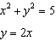

- a) Algebraically determine the roots, in simplest form, to the equation below.

b) Consider the system of equations below.
The graph of this system confirms the solution from part a is imaginary. Explain why.

- What is the inverse of the function ? Show all work in order to receive full credit.
(a) 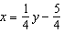 (b) 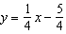 (c) (d) 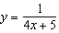

- Consider the system of equations below:
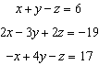
Which number is not the value of any variable in the solution of the system? Show all work in order to receive full credit.
- -1 (b) 2 (c) 3 (d) -4

