Name: _________________________________ Algebra II
Score: ______ / 20
Period: _____________ Cumulative Review #5.1
Directions: Show all work in order to receive full credit. A correct answer with no supporting work will only receive one credit. Be sure to show all appropriate formulas and formula substitutions as part of your work.
- Solve the following equation. $\frac{3}{x-3}=\frac{1}{x-1}+\frac{7}{\left(x-1\right)\left(x-7\right)}$

- If 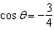 and is in Quadrant III, then is equivalent to
1) | 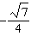 | 3)
2) |  | 4)

- Which binomial is not a factor of the expression $x³-11x^{2}+16x+84$? [show all work for full credit]

  - x+2 b. x+4 c. x–6 d. x–7

- a. Graph $f\left(x\right)=x^{3}-2x-4$.
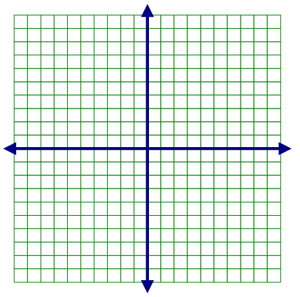
b. Based on the graph, what is the real solution to the equation $x^{3}-2x-4=0$?

c. Write f(x) as a product of a linear and a quadratic factor.

