EXTRA REVIEW
Quiz 2.2

Directions: Show all work in order to receive full credit.

- Write the quadratic equation that has as its roots $7+2i$ and $7-2i$

- Solve algebraically for all real and imaginary values of x in simplest form.

$$x^{4}+4x^{3}+4x^{2}+16x=0$$

- Find the sum and product of the roots of the equation $7x^{2}-10x+1=0$

- Find all values of k such that the equation $5x^{2}-3x+k=0$ has imaginary roots.

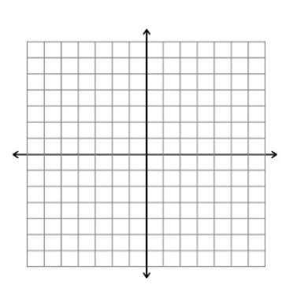
- Using your calculator, sketch the graph of $y=x^{3}-3x^{2}+2x+1$ on the grid below. State the solution set of the equation$x^{3}-3x^{2}+2x+1=0$.

