Extra Review #4.1A
Directions: Show all work in order to receive full credit. A correct answer with no supporting work will only receive one credit. Be sure to show all appropriate formulas and formula substitutions as part of your work.
- Express in simplest form: 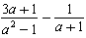

- Simplify: 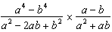

- Solve: $\frac{10}{2y+8}-\frac{7y+8}{y^{2}-16}=\frac{-8}{2y-8}$

