Extra Review #4.1A
Directions: Show all work in order to receive full credit. A correct answer with no supporting work will only receive one credit. Be sure to show all appropriate formulas and formula substitutions as part of your work.
- Express in simplest form: 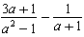

- Determine if $(x – 2)$ is a factor of ${3x}^{3}-4x+2$. Explain your answer.

- Solve: $\frac{10}{2y+8}-\frac{7y+8}{y^{2}-16}=\frac{-8}{2y-8}$

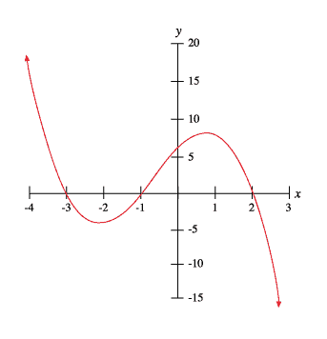
- Given the graph to the right,
  - Determine all roots of the function.

  - List all factors of the function.

  - Write a possible equation for this function in standard form.

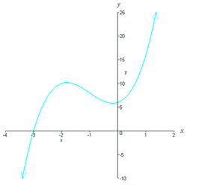
- Given the graph of $f\left(x\right)= x^{3}+6x^{2}+13x+12$. Write the function as a product of its linear and quadratic factor.

