Name: ______________________________________ Power/Exponent/Log Regression HW
1. The table below shows the results of an experiment involving the growth of bacteria.
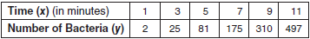
Write a power regression equation for this set of data, rounding all values to three decimal places.

Using this equation, predict the bacteria’s growth, to the nearest integer, after 15 minutes.

2. The accompanying table shows wind speed and the corresponding wind chill factor when the air temperature is 10ºF.
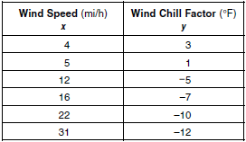
Write the logarithmic regression equation for this set of data, rounding coefficients to the nearest ten thousandth.

Using this equation, find the wind chill factor, to the nearest degree, when the wind speed is 50 miles per hour.

Based on your equation, if the wind chill factor is 0, what is the wind speed, to the nearest mile per hour?
3. A box containing 1,000 coins is shaken, and the coins are emptied onto a table. Only the coins that land heads up are returned to the box, and then the process is repeated. The accompanying table shows the number of trials and the number of coins returned to the box after each trial.
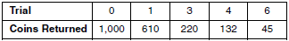
Write an exponential regression equation, rounding the calculated values to the nearest ten-thousandth.

Use the equation to predict how many coins would be returned to the box after the eighth trial.

