Express each answer in simplest radical form.
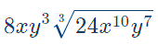

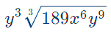

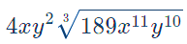

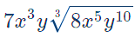

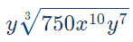

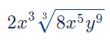

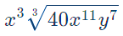

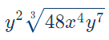

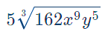

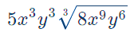

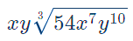

If you’ve finished all the problems on this page, move on to tonight’s HW: p. 93-94 #1, 10-45 mutliples of 5 & remember to study for Wednesday’s Quiz!

