If you need more practice with … here are some things to remember & practice!
Finding Complex Roots
- By Quadratic Formula/Completing the Square (#1 quiz 2.2)
Remember…
- $x=\frac{-b±\sqrt{b^{2}-4ac}}{2a}$
- Never include x in the quadratic formula on the right side
- $\sqrt{-1}=i$
Examples: Solve for all values of x in simplest a+bi form.
- $9x²+24x=-19$ b) $4x²-8x+7=0$

Factoring by Grouping to Solve Polynomials (#4 quiz 2.2)
Remember…
- This occurs when we have four terms
- Write in standard form and group into two binomials
- Pull out a GCF from each and write as two factors (factors imply multiplication)
- Set each factor equal to zero to solve for all solutions
Examples:
- $x^{5}+4x^{4}-25x³-100x²=0$ b) $2x³-5x^{2}-4x+10=0$

- From Factored Forms (#2 quiz 2.2)
Remember…
- Set each factor =0 individually to solve like separate equations
Examples: Find the zeros of each function.
- $H\left(x\right)=-3(x^{2}-49)(x^{2}+4)$ b) $J\left(x\right)=x(7x-3)(x^{2}+81)$

Sketching Curves/Solving Polynomials Graphically
- Given Factored Form of Polynomial (#3 quiz 2.2)
Remember…
- Negate factors to determine roots
- Pay attention to which numbers are larger according to the question
- Note details of including all intercepts
Examples: Sketch the curves given the equations below. Include all intercepts.
- $f\left(x\right)=-x²(x-4)(x+3)²$ b) $g\left(x\right)=(2x+2)(x-1)(x+4)²$

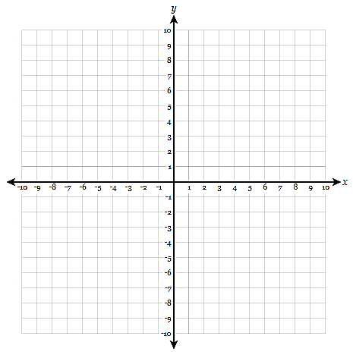

- Given a Polynomial in Standard Form (#5 quiz 2.2)
Remember…
- Type equation into y= in your calculator
- Use the table to plot ALL points in the table that fit in the graph
Examples: Graph the following functions and state all solutions.
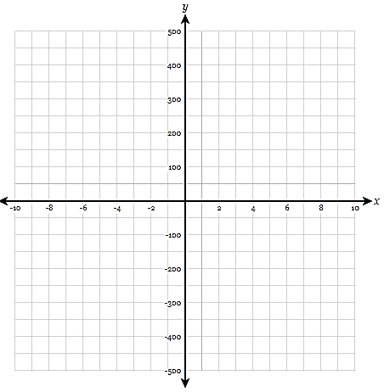
- $f\left(x\right)=x³+x²-46x+80$ b) $h\left(x\right)=x^{4}-49x^{2}+36x+252$
