Revew for Quiz #7.1

- State an equation of each function shown.

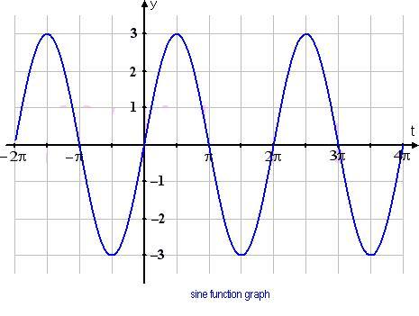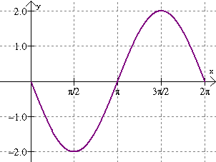
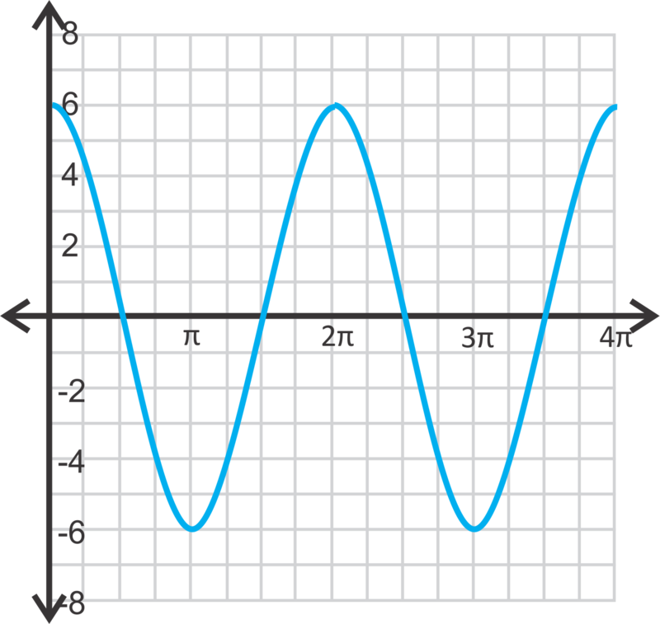

- Sketch the graph of $y=-2\cos{2x}$ over the interval $-2π≤x≤2π$

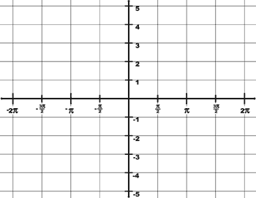

- What is the amplitude, period and frequency of the graph of the equation $y=-3\cos{\frac{1}{4}x}$?

- A function, $y=f(x)$ is represented by the graph shown. The function is transformed to create a new function $g\left(x\right)=3f\left(x\right)-4$. Sketch the new function, $g(x)$ on the same set of axes.

