Unit 6 Review Sheet
- Convert the following radian measures to degrees:
  - $\frac{π}{3}$ b. $\frac{2π}{5}$ c. $\frac{13π}{4}$

- Convert the following degree measures to radians:
  - $270°$ b. $-110°$ c. $405°$

- If $\cos{A= -\frac{8}{ 17}}$ and $\tan{A>0}$, find:
  - sin A b. tan A c. A to the nearest degree

d. csc A e. cot A f. sec A

- If the terminal side of $θ$, in standard position, passes through the point $(12, -5)$, what is the numerical value of:
  - sin $θ$ b. cos $θ$ c. cot $θ$

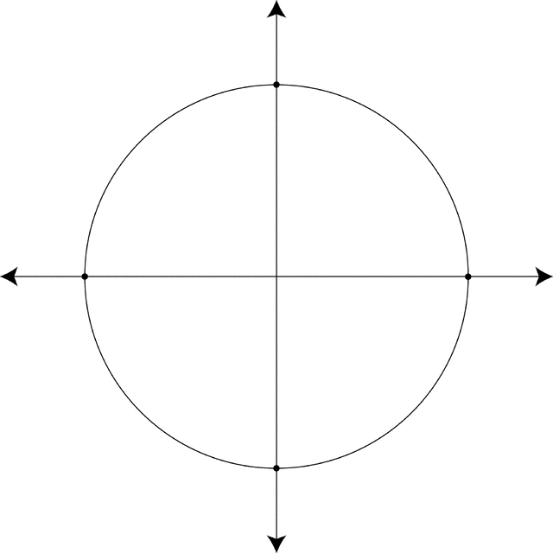
- a. On the unit circle shown, sketch an angle in standard position that measures $\frac{5}{2}π$ radians.

b. What is the point of intersection between the angle and the unit circle?

c. Name another angle, in radian measure that passes through the same point.

- What is the length of the arc on the unit circle subtended by an angle of $220°$?

- a. On the unit circle shown, sketch an angle in standard position that measures$135°$.

b. Find the exact value of $\cos{135°}$.

- Simplify $\frac{1}{\cos^{2}θ}- \tan^{2}θ$.

- Find the exact value of $\tan{\frac{π}{4}-\cos{\frac{π}{3}+\sin{\frac{π}{3}}}}$.

