A2 Unit 7 Review Sheet #1
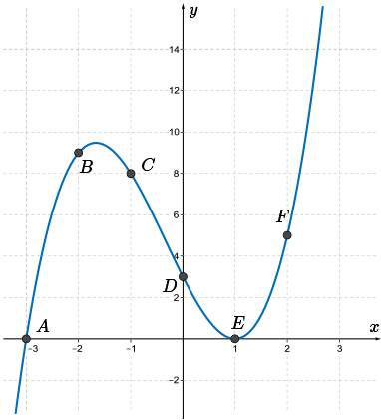
- Write an equation for the graph shown. Show all work that leads to your answers.

- Solve the system of equations shown:
$$x + y – z = -1$$
$$2x – 2y + 3z = 8$$
$$2x – y + 2z = 9$$

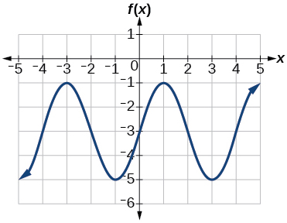
- Determine the equation for the function shown:

- Write the following quadratic in vertex form. Determine the vertex of the function.
$$y=3x^{2}-6x+5$$

- Determine if $(x – 3)$ is a factor of ($3x^{3}+2x-11)$. Explain your reasoning.

- Determine the cosine equation that has an amplitude of 4, frequency of 2, and a midline of 5.

- Graph one cycle of each function on the same set of axes: $y= \frac{-1}{2}sinx$

$$y= -cos2x$$

- The depth of the water at a generating station can be represented by the graph shown:
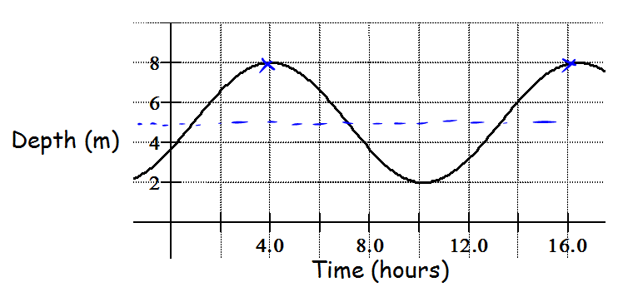
  - Determine a possible function for this graph.
  - Calculate the depth of the water at 9:30 am (assuming $x = 0$ is midnight).
  - Based on your graph, determine the amplitude, period and midline of the function
  - Explain the meaning of the amplitude in context with this problem.

