- The angle 210$°$ is equivalent to
  - $\frac{5π}{6}$ degrees (2)$\frac{7π}{6}$ degrees
(3) $\frac{5π}{6}$ radians (4) $\frac{7π}{6}$ radians

2. What is the value of $i^{42}?$
- $i$ (2) $1$
(3) $-i$ (4) $-1$

3. If $\sec{θ>0 }$and $\tan{θ<0}$,
- Quadrant I (2) Quadrant II
(3) Quadrant III (4) Quadrant IV

4. The exact value of $\sin{\frac{13π}{6}}$ is
- $\frac{1 }{2}$ (2) $\frac{-1 }{2}$
(3)$\frac{\sqrt{2}}{2}$ (4) $\frac{\sqrt{3}}{2}$

5. An angle of $\frac{3π}{2}$ on the unit circle has coordinates of
- $\left(\frac{1 }{2},\frac{\sqrt{3}}{2}\right)$ (2) $\left(-\frac{\sqrt{2}}{2},\frac{\sqrt{2}}{2}\right)$
(3) (0, -1) (4) (-1, 0)

6. If $(\tan{θ)(\sin{θ)<0}}$, then the angle $θ$ could terminate in quadrants
- II or III (2) II or IV
(3) I or IV (4) III or IV

7. The exact value of $sin\left(\frac{-π}{3}\right)+\cos\left(\frac{5π}{4}\right)$ is:
- $\frac{-\sqrt{3}-\sqrt{2}}{2}$ (2) $\frac{-\sqrt{3}+\sqrt{2}}{2}$
(3) $\frac{\sqrt{3}-\sqrt{2}}{2}$ (4) $\frac{\sqrt{6}}{2}$

8. 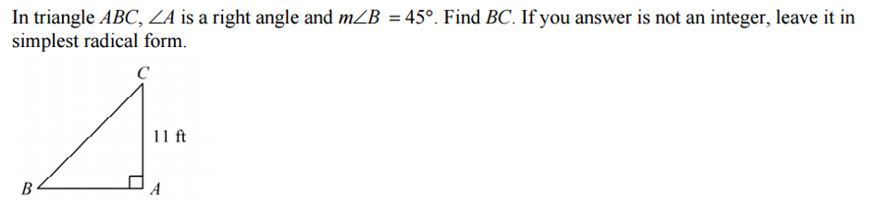
- $22$ (2) $22\sqrt{2}$
(3) $11$ (4) $11\sqrt{2}$

9. Calculate the value of $a$ in the diagram below

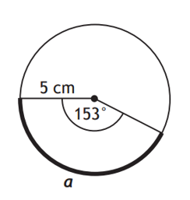

10. Simplify $\frac{\cos{θ\tan{θ}}}{\sin{θ}}$ to lowest terms.

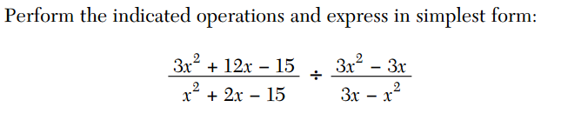
11.

12. Given that $\sec{θ=\frac{5}{4}}$ and $\sin{θ<0}$ then calculate each of the following:

(a) $\sin{θ}$

(b) $\cos{θ}$

(c) $\tan{θ}$

(d) $\csc{θ}$

(e) $\cot{θ}$

(f) The value of $θ$ to the nearest tenth of a degree

