Name: _____________________________ Unit 1 Review – Polynomials & Complex Numbers
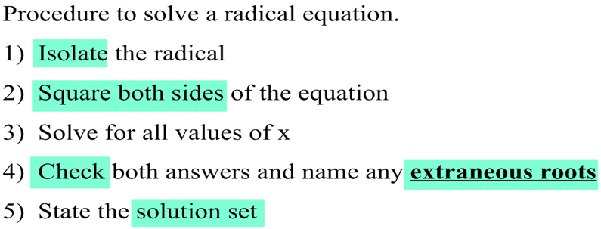
Helpful Information:
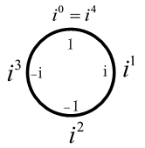
iClock

Level I Practice:
- The solution set for the equation is
1)
2)
3)
4)
- Express in form.

- Simplify each of the expressions completely:
  - $5\sqrt[3]{9y²}∙\sqrt[3]{24y}$ b. $\frac{\sqrt[3]{81x^{5}y^{3}}}{\sqrt[3]{3x^{2}}}$

Level II Practice:
- Given i is the imaginary unit, in simplest form is
1)
2)
3)
4)
- The power P, in watts, that a circular solar cell produces and the radius of the cell r in centimeters are related by the square root equation $r=\sqrt{\frac{P}{0.02π}}$. About how much power is produced by a cell with a radius of 12 cm?

- Twyla and Ben are simplifying $4\sqrt{32}+6\sqrt{18}$. Is either of them correct? Explain your reasoning.
TWYLA | BEN
$$4\sqrt{32}+6\sqrt{18}$$  $$4∙\sqrt{4^{2}∙2}+6\sqrt{3^{2}∙2}$$  $$16\sqrt{2}+18\sqrt{2}$$  $$34\sqrt{2}$$ | $$4\sqrt{32}+6\sqrt{18}$$  $$4∙\sqrt{16∙2}+6\sqrt{9∙2}$$  $$64\sqrt{2}+54\sqrt{2}$$  $$118\sqrt{2}$$

Level III Practice:
- The speed of a tidal wave, s, in hundreds of miles per hour, can be modeled by the equation , where t represents the time from its origin in hours. Algebraically determine the time when . How much faster was the tidal wave traveling after 1 hour than 3 hours, to the nearest mile per hour? Justify your answer.

- Simplify completely: $\left[\left(2+i\right)x²-ix+5+1\right]-\left[\left(-3+4i\right)x²+\left(5-5i\right)x-6\right]$

- The expression 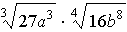 is equivalent to
1)
2)
3)
4)

