Name: _____________________________ Unit 2 Review – Quadratics
Helpful Information:
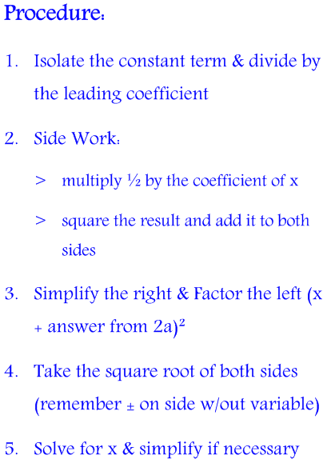
Types of Factoring: Completing the Square: Nature of Roots:
- GCF determined by
- Difference of Two Squares discriminant
- Trinomial (regular & grouping) $b²-4ac$

Quadratic Formula: $x=\frac{-b±\sqrt{b^{2}-4ac}}{2a}$

Standard Form: $y=ax²+bx+c$
Vertex Form: $y=\frac{1}{4p}\left(x-h\right)²+k$
where, p = distance from focus to vertex and vertex to directrix, and (h,k) represents the vertex

Level I Practice:
1 | 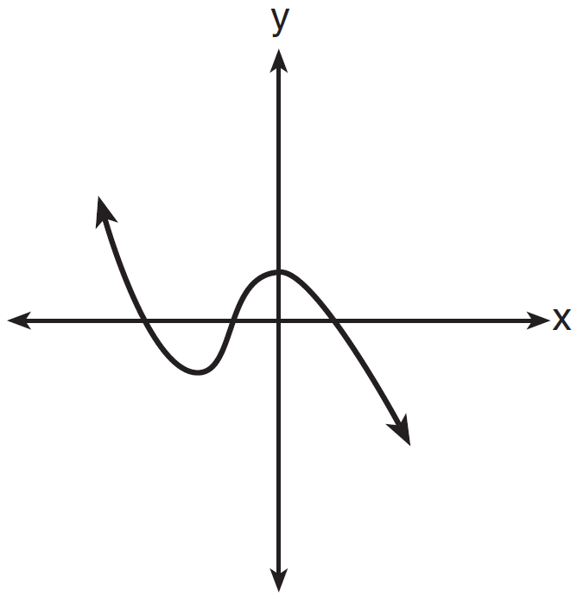 | 2 | 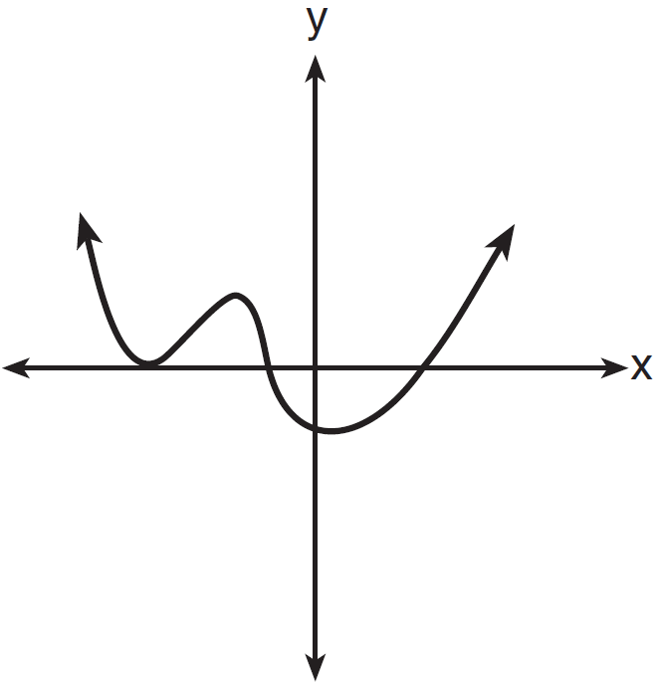
3 | 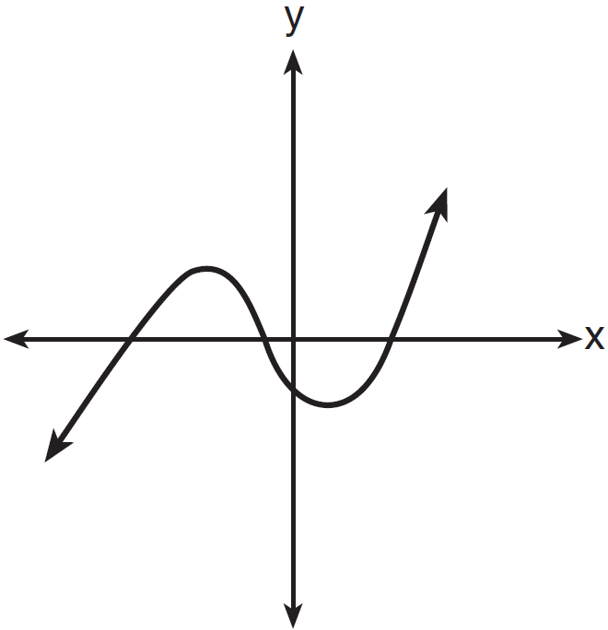 | 4 | 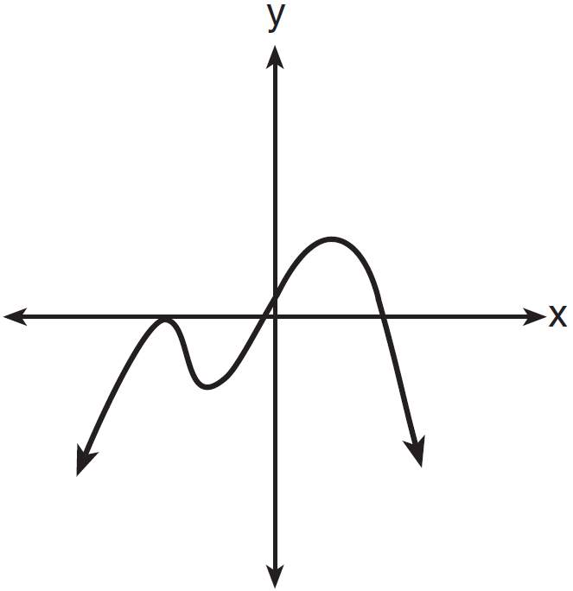
- Which graph has the following characteristics?
• three real zeros
•
•

- The zeros for are
1)
2)
3)
4)

- The directrix of the parabola has the equation . Find the coordinates of the focus of the parabola.

- Factored completely, is equivalent to
1)
2)
3)
4)

- The solution to the equation is
1) | 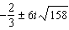
2) | 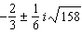
3) | 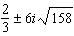
4) | 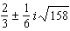
Level II Practice:
- A solution of the equation is
1) | 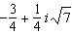
2) | 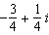
3) | 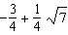
4)

- There was a study done on oxygen consumption of snails as a function of pH, and the result was a degree 4 polynomial function whose graph is shown below.
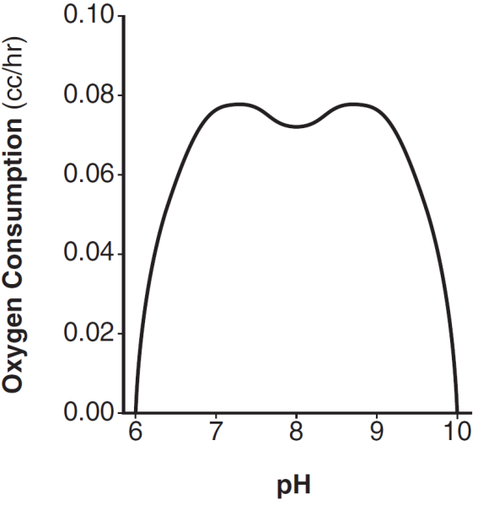
Which statement about this function is incorrect?
1) | The degree of the polynomial is even.
2) | There is a positive leading coefficient.
3) | At two pH values, there is a relative maximum value.
4) | There are two intervals where the function is decreasing.

- On the grid below, sketch a cubic polynomial whose zeros are 1, 3, and -2.

Level III Practice:
- The equation is equivalent to
1)
2)
3)
4)

- Algebraically determine the values of h and k to correctly complete the identity stated below.

