Name: _____________________________ Unit 3 Review – Systems of Equations
Helpful Information:
The solution(s) to a system of equations is where the graphs intersect

2 x 2 Systems
Solutions contain (x,y)
Look for multiple solutions
Can be solved algebraically or graphically
3 x 3 Systems
Solutions contain (x,y,z)
Look for a single solution
Only solved algebraically w/ elimination method

Level I Practice:
- When 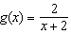 and are graphed on the same set of axes, which coordinates best approximate their point of intersection?
1)
2)
3)
4)
- Solve the following system of equations algebraically:
$$-5x-y-4z=60$$
$$2x+4y+3z=-12$$
$$6x-3y-2z=-52$$

- Solve the following system of equations algebraically:
$$3x+4y=8$$
$$x-3y=-6$$

Level II Practice:
- Which value, to the nearest tenth, is not a solution of if and ?
1)
2)
3) | 2.1
4) | 4.7
- What is the solution to the system of equations and where is defined by the function below?
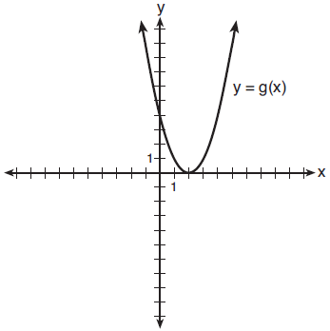
1)
2)
3)
4)
- Solve the following system of equations algebraically:
$$4a+5b-6c=2$$
$$-3a-2b+7c=-15$$
$$-a+4b+2c=-13$$

Level III Practice:
- Solve the system of equations shown below algebraically.
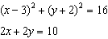

- A friend e-mails you the results of a recent high school swim meet. The e-mail states that 24 individuals placed, earning a combined total of 53 points. First place earned 3 points, second place earned 2 points, and third place earned 1 point. There were as many first place finishers as second and third place finishers combined.
  - Write a system of three equations to represent how many people finished in each place.

  - How many swimmers finished in first place, second place, and third place, respectively?

