Name: _____________________________ Unit 4 Review – Rationals
Helpful Information:
Multiplying – Factor and cancel common factors between the numerator and denominator
Dividing – Keep Change Flip (aka multiply by the reciprocal)
Adding/Subtracting – Find common denominators
Synthetic Division (uses the root) is a shortcut for Long Division (uses the whole polynomial) that can only be used when the leading coefficient of the binomial you divide by is 1
If something is a factor of a polynomial you can check by (remember if it is short answer you need to be able to show work):
- Synthetic division will have no remainder
- Long Division will have no remainder
- Evaluating the function at the root will give you 0
- Look for a root on the graph (where it crosses the x-axis)
- Look in the table for the x-value when y=0
Rational Root Theorem - potential roots of a polynomial are found by finding all the positive and negative values of the factors of the last term divided by the factors of the first term
Level I Practice:
- The zeros for are
1)
2)
3)
4)
- Solve for x: 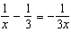

- When is divided by , the remainder is 0. Given , which conclusion about is true?
1)
2)
3) | is a factor of .
4) | No conclusion can be made regarding .

Level II Practice:
- The expression 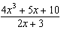 is equivalent to
1) | 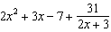
2) | 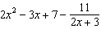
3) | 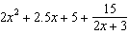
4) | 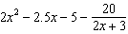
- Determine if is a factor of . Explain your answer.

- Algebraically prove that 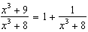, where .

Level III Practice:
- What is the solution, if any, of the equation 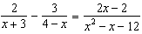?
1) | -1
2) | -5
3) | all real numbers
4) | no real solution

- Given and , state the quotient and remainder of , in the form 

