Name: _____________________________ Unit 5 Review – Functions
Helpful Information:
Function – x-values can NOT repeat (vertical line test)
Domain – x-values Range- y-values
One-To-One – function in which y-values can NOT repeat (horizontal line test)
Inverse – $f^{-1}\left(x\right)$ – switch x and y, then solve for y
Composition – $f\left(g\left(x\right)\right)=\left(f ⃘g\right)\left(x\right) (f\left(f^{-1}\left(x\right)\right) used to prove inverses)$
Transformations – (remember x changes opposite)
 | Reflection | Dilations | Translations
Changes on x | $$f\left(-x\right)$$ | $$f\left(a∙x\right)$$ | $$f\left(x+a\right)$$
Changes on y | $$-f\left(x\right)$$ | $$a∙f\left(x\right)$$ | $$f\left(x\right)+a$$
Even Functions – symmetric about the y-axis ($f\left(x\right)=f\left(-x\right)$) **Example: $y=\cos{x}$
Odd Functions – symmetric about the origin (180º rotation) ($-f\left(x\right)=f\left(-x\right)$) **Example: $y=\sin{x}$
Level I Practice:
- If and , then equals
1)
2)
3)
4)
- Are the given functions inverses? Justify your answer.
$$f\left(x\right)=-6x$$
$$g\left(x\right)=\frac{1}{6}x$$

- Which equation represents an odd function?
1)
2)
3)
4)
Level II Practice:
- Given 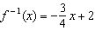, which equation represents ?
1) | 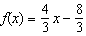
2) | 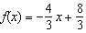
3) | 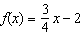
4) | 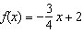
- Find $\left(f-g\right)\left(x\right)$ given that $f\left(x\right)=3x²-4$ and $g\left(x\right)=x²-8x+4$.

- Sketch a graph of the function $y=2x³$. Is the function odd, even, or neither? Explain your answer.

Level III Practice:
- If and , then which statement is not true?
1)
2)
3)
4) | 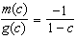

- Which statement regarding the graphs of the functions below is untrue?
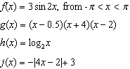
1) | and have a maximum y-value of 3.
2) | , , and have one y-intercept.
3) | and have the same end behavior as .
4) | , , and have rational zeros.

- Show the inverse of a linear function $y=mx+b$, where $m≠0$ and $x≠b$, is also a linear function.

- Functions f, g, and h are given below. Which statement is true about functions f, g, and h?
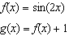
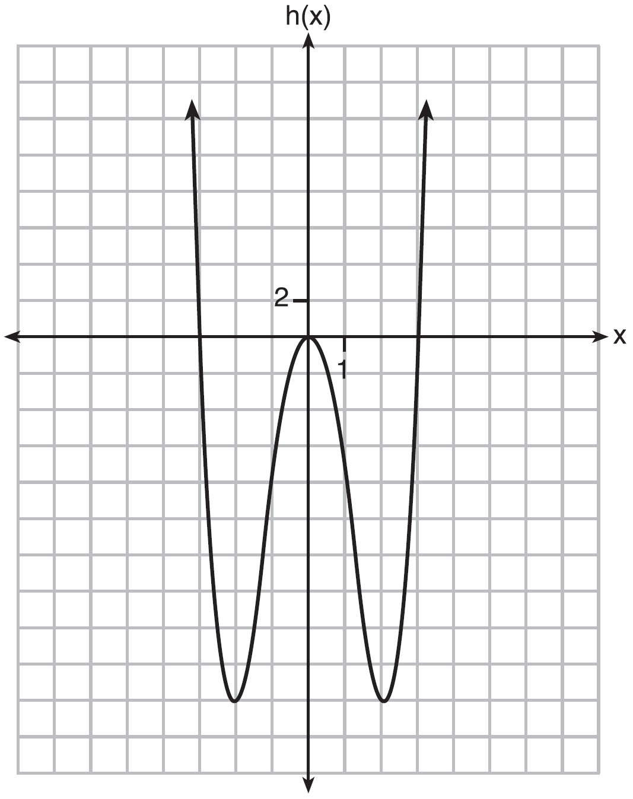
1) | and are odd, is even.
2) | and are even, is odd.
3) | is odd, is neither, is even.
4) | is even, is neither, is odd.

