Algebra 2- Unit 5: Relations & Functions Review Sheet #1
- Classify the symmetry of $f\left(x\right)= -3x^{2}+6x-2$ as even, odd, or neither. Justify your answer.

- Given $f(x) = -3x + 1$. Find the inverse and use compositions to prove your answer.

- Solve algebraically for y: $8- \frac{7}{y+2}= \frac{-5}{y-1}$

- Michael graphs$y= x^{2}$. He then performs various transformations on his graph and determines a new function $y= -{\left(x+3\right)}^{2}-2$. Explain in words what happened to the original function.

- Determine the domain of $(x) =$ $\frac{-2x}{x^{2}-9}$.

- Given $f\left(x\right)= \frac{x+1}{2}$ and $g\left(x\right)= -(3-x)$.
  - Find $f(g\left(-1\right).$

  - Find $f^{-1}\left(x\right)$ and $g^{-1}\left(x\right)$.

  - Solve the equation $\left(g° f^{-1}\right)\left(x\right)=3$.

- Is {(9, 0), (8, 9), (-3, -3), (0, -5)} 1-1? Onto? Explain your answer.

- Given $M\left(2, 3\right), A\left(9, 2\right), T\left(-6, -4\right), H(-1, 1)$. Determine the new coordinates after a reflection over the x- axis.

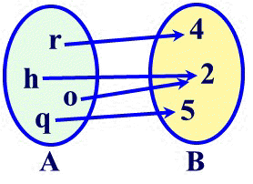
- Given: Determine if this mapping is a function. If it is, determine if it is 1-1 or onto.

