Name: _____________________________ Unit 6 Review – Trigonometry & the Unit Circle

Helpful Information:
 | $$\sin{θ}$$ | $$\cos{θ}$$ | $$\tan{θ}$$
0º / 0 rad | $$\frac{\sqrt{0}}{2}=0$$ | $$\frac{\sqrt{4}}{2}=1$$ | $$0$$
30º /$\frac{π}{6}$ rad | $$\frac{\sqrt{1}}{2}=\frac{1}{2}$$ | $$\frac{\sqrt{3}}{2}$$ | $$\frac{1}{\sqrt{3}}$$
45º / $\frac{π}{4}$ rad | $$\frac{\sqrt{2}}{2}$$ | $$\frac{\sqrt{2}}{2}$$ | $$1$$
60º / $\frac{π}{3}$ rad | $$\frac{\sqrt{3}}{2}$$ | $$\frac{\sqrt{1}}{2}=\frac{1}{2}$$ | $$\sqrt{3}$$
90º / $\frac{π}{2}$ rad | $$\frac{\sqrt{4}}{2}=1$$ | $$\frac{\sqrt{0}}{2}=0$$ | und.
Reference angles always drawn from the x-axis
$$\left(x,y\right)→\left(\cos{θ,}\sin{θ}\right)$$

Trig Identities & Pythagorean Identities
- $\sin^{2}{x}+\cos^{2}{x=1}$
- $\tan{x}=\frac{\sin{x}}{\cos{x}}$
- $\csc{x=\frac{1}{\sin{x}}}$
- $\sec{x}=\frac{1}{\cos{x}}$
- $\cot{x}=\frac{1}{\tan{x}}=\frac{\cos{x}}{\sin{x}}$
π radian = 180º
Remember what is positive in each quadrant:
- All Students Take Calculus
- Alvin, Simon, and Theodore are the Chipmunks

Level I Practice:
- If , then M equals
1) | 32°
2) | 58°
3) | 68°
4) | 72°
- Tarisha and Alan are writing an expression for the measure of an angle coterminal with the angle shown at the right. Is either of them correct? Explain your reasoning.
Tarisha | Alan
The measure of a coterminal angle is $\left(x-360\right)º$ | The measure of a coterminal angle is $\left(360-x\right)º$

- Determine whether $3\sin{60º}=\sin{180}º$ is true or false. Explain your reasoning.

- In the diagram below of right triangle KTW, KW=6, KT=5, and m<KTW=90. What is the measure of <K, to the nearest minute?
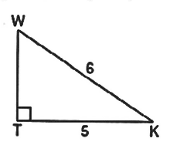
  - 33º33’ b. 33º34’ c. 33º55’ d. 33º56’
Level II Practice:
- If the terminal side of angle , in standard position, passes through point , what is the numerical value of ?
1)
2)
3)
4)
- A shadow moves around a sundial 15º every hour.
  - After how many hours is the angle of rotation of the shadow $\frac{8π}{5}$ radians?

  - What is the angle of rotation in radians after 5 hours?

- Jordan and Ebony are simplifying $\frac{\sin{²θ}}{\cos{²θ}+\sin{²θ}}$. Is either correct? Explain your reasoning.
Jordan | Ebony
$\frac{\sin{²θ}}{\cos{²θ}+\sin{²θ}}$  $$=\frac{\sin{²θ}}{\cos{²θ}}+\frac{\sin{²θ}}{\sin{²θ}}$$  $$=\tan{²θ}+1$$  $=\sec{²θ}$ | $\frac{\sin{²θ}}{\cos{²θ}+\sin{²θ}}$  $$=\frac{\sin{²θ}}{1}$$  $$=\sin{²θ}$$

- In which graph is $θ$ coterminal with an angle of $-70º$?
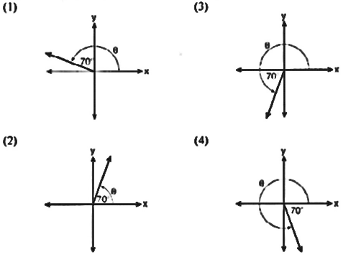
Level III Practice:
- Using the unit circle below, explain why 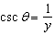.
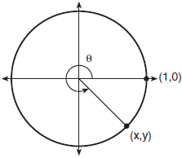
- Simplify the following expression by writing it in terms of $\sin{θ}$: $\frac{\sec{θ}}{\cot{θ+\tan{θ}}}$

- A circle centered at the origin has a radius of 10 units. The terminal side of an angle, , intercepts the circle in Quadrant II at point C. The y-coordinate of point C is 8. What is the value of ?
1)
2)
3)
4)

- In the diagram below of right triangle JTM, JT=12, JM=6, and m<JMT=90. What is the value of cotJ?
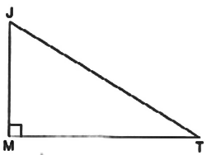
  - $\frac{\sqrt{3}}{3}$ b. 2 c. $\sqrt{3}$ d. $\frac{2\sqrt{3}}{3}$

