Name: _____________________________ Unit 7 Review – Trig Graphs
Helpful Information:
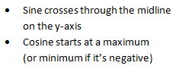
$y=A\sin\left(F\left(x+H\right)\right)+V$
  - sin can be replaced with cos
  - A = amplitude (distance from midline to max)
  - F = frequency (# cycles in a 2π interval)
  - H = horizontal shift (shifts opposite)
  - V = vertical shift (midline)
Level I Practice:
- The Ferris wheel at the landmark Navy Pier in Chicago takes 7 minutes to make one full rotation. The height, H, in feet, above the ground of one of the six-person cars can be modeled by 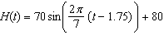, where t is time, in minutes. Using for one full rotation, this car's minimum height, in feet, is
1) | 150
2) | 70
3) | 10
4) | 0
- Which graph represents a cosine function with no horizontal shift, an amplitude of 2, and a period of ?
1) | 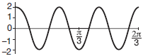 | 3) | 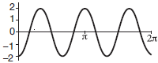
2) | 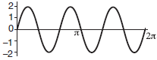 | 4) | 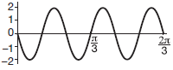
- The accompanying graph shows a trigonometric function. State an equation of this function.
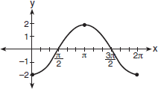

- Which statement is incorrect for the graph of the function 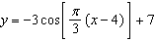?
1) | The period is 6.
2) | The amplitude is 3.
3) | The range is [4,10].
4) | The midline is .

Level II Practice:
- On the axes below, graph one cycle of a cosine function with amplitude 3, period , midline , and passing through the point .
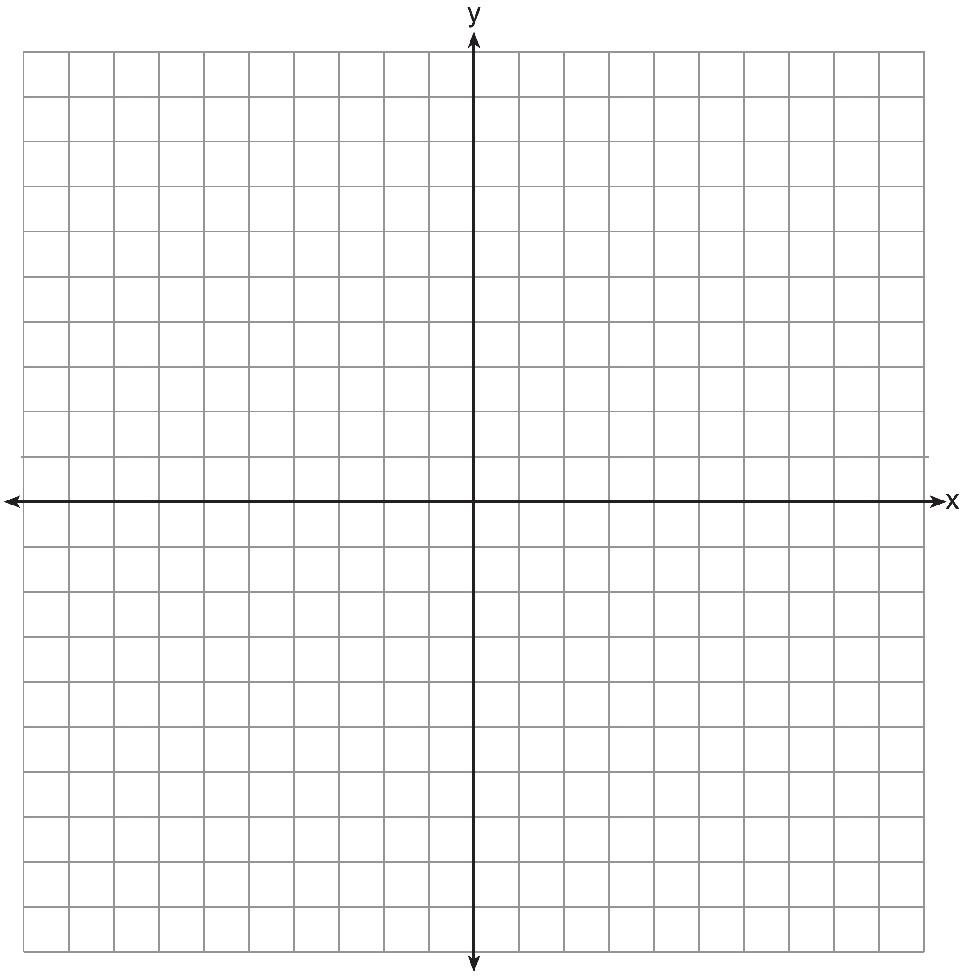

- Relative to the graph of , what is the shift of the graph of 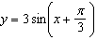?
1) | right
2) | left
3) | up
4) | down
- Write an equation for the graph of the trigonometric function shown below.
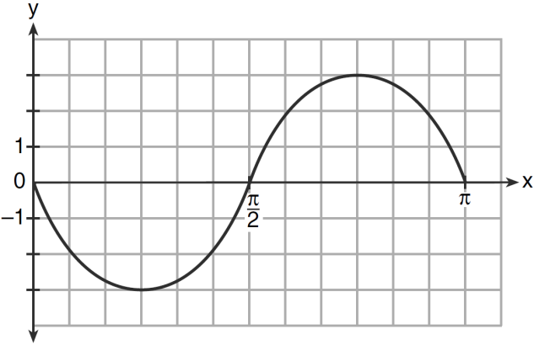

- The periodic graph below can be represented by the trigonometric equation where a, b, and c are real numbers.
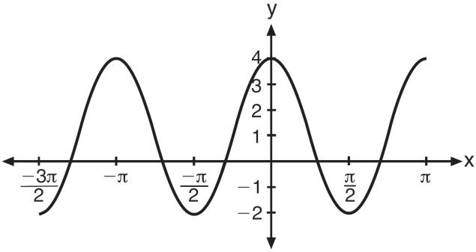
State the values of a, b, and c, and write an equation for the graph.

Level III Practice:
- The voltage used by most households can be modeled by a sine function. The maximum voltage is 120 volts, and there are 60 cycles every second. Which equation best represents the value of the voltage as it flows through the electric wires, where t is time in seconds?
1)
2)
3)
4)

- The ocean tides near Carter Beach follow a repeating pattern over time, with the amount of time between each low and high tide remaining relatively constant. On a certain day, low tide occurred at 8:30 a.m. and high tide occurred at 3:00 p.m. At high tide, the water level was 12 inches above the average local sea level; at low tide it was 12 inches below the average local sea level. Assume that high tide and low tide are the maximum and minimum water levels each day, respectively. Write a cosine function of the form , where A and B are real numbers, that models the water level, , in inches above or below the average Carter Beach sea level, as a function of the time measured in t hours since 8:30 a.m.
On the grid below, graph one cycle of this function.
People who fish in Carter Beach know that a certain species of fish is most plentiful when the water level is increasing. Explain whether you would recommend fishing for this species at 7:30 p.m. or 10:30 p.m. using evidence from the given context.

