A2CC - Unit 7 Review - Trig Graphs Name___________________________

____ 1. Write $y=x^{2}-5x+2$ in vertex form.

____ 2. What equation is represented by the graph below?
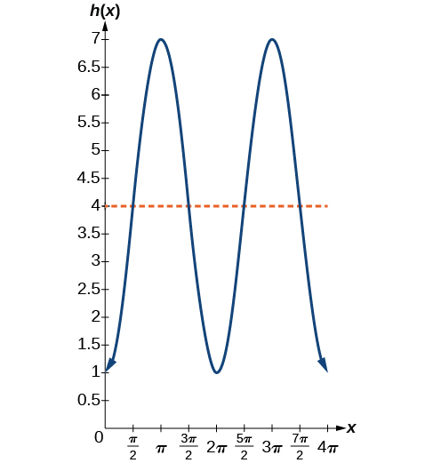

____ 3. Write a cosine function has a period of 4$π$ a midline of y = -5 a maximum value of 2?

____ 4. Express $y=-2\sin\left(x\right)$ as a function of $cos⁡(x)$.

____ 5. Divide $f\left(x\right)=2x^{3}+x^{2}-4x+4$ by $\left(x+2\right)$.

____ 6. Solve the following system of equations:

$$x-2y+3z=7$$
$$2x+y+z=4$$
$$-3x+2y-2z=-10$$

.

____ 7. Given the graph below, express the equation of this function, and explain your reasoning.

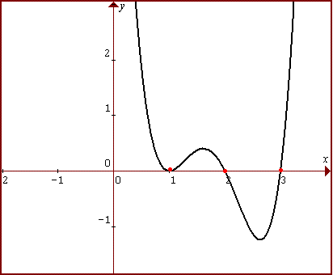

8.
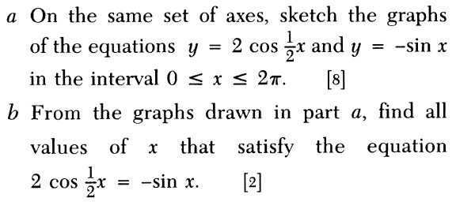

9. Steamboat Problem: Mark Twain sat on the deck of a river steamboat. As the paddle wheel turned, a point on the paddle blade moved so that its distance, d, in feet, from the water’s surface was a sinusoidal function of time t, in seconds. When Twain’s stopwatch read 4 s, the point was at its highest, 16 ft above the water’s surface. The wheel’s diameter was 18 ft , and it completed a revolution every 10 s.

a. Sketch the graph of the sinusoid.

b. What is the lowest the point goes? Why is it reasonable for this value to be negative?

c. Find a particular equation for distance as a function of time.

d. How far above the surface was the point when Mark’s stopwatch read 17 s?

e. What is the first positive value of t at which the point was at the water’s surface?
At that time, was the point going into or coming out of the water? How can you tell?

Bonus: “Mark Twain” is a pen name used by Samuel Clemens. What is the origin of that pen name? Give the source of your information.

